3.7 Russia (endogenous)
In an extension of the model Russia has been included as a model country. To allow a more detailed modelling, Russia (RU) consists of three regions; RU1, RU2 and RU3, which are treated as three separate countries in the model. This captures the complexity of the Russian energy market better than if it was treated as one country.
Russia consists of 83 federal subjects or regions. In 2000 these were grouped into seven official federal districts following a presidential decree. A lot of the official Russian statistical data is presented on a federal district level. In the model the three countries RU1, RU2 and RU3 (from now on referred to as regions) are aggregates of the seven official Russian Federal districts where RU1 corresponds to the Central Federal District, Volga Federal District, Northern Caucasus Federal District, North Western Federal District and Southern Federal District, RU2 to Ural Federal District and RU3 to Siberia and the Far Eastern Federal District.
Figure 5 Map of Russian regions in LIBEMOD
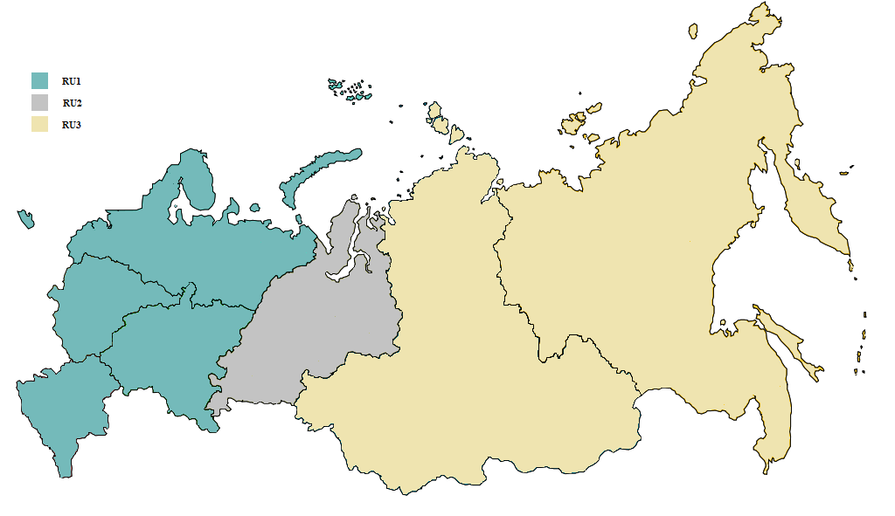
As far as possible the three Russian regions have been treated in exactly the same way as the other model countries. Various additional Russian sources have been used to get a complete dataset for each region. A lot of official Russian statistics is available on a federal district level, which has made it possible to create datasets for RU1, RU2 and RU3. However, in some instances the hunt for data on a regional level has not been successful and own assumptions have been made.
The following chapters address these data issues and outline sources and assumptions. Where we have used the same input parameters as for the other model countries this is generally not described below and the reader is referred to the previous chapters. This does for instance apply to the cost data for new power plants.

3.7.1 Quantities
The IEA Extended World Energy Balances database (IEA 2010) has a full set of consumption data for Russia, but due to the regional structure in the model additional data sources and own assumptions have been used to complete the dataset. A comprehensive data source for energy consumption on a federal district level for Russia has not been identified and information regarding sectorial consumption is generally hard to find. The sources are mainly Russian, and vary between energy goods. Below is an outline of the data sources and assumptions for each of the energy goods included in the model. To ensure consistency within the model the energy balance from IEA Extended Energy Balances has been used as the total for Russia (the sum of RU1, RU2 and RU3).
The IEA has national data for electricity consumption for each of the LIBEMOD sectors, whereas the Russian Electricity Systems Operator UPS publishes data on the total regional consumption. ABPE (2011) has consumption data for all the federal districts by sector for 2009. The totals for each sector are not quite the same, so the IEA total is used for each sector, and the consumption in the three regions is allocated based on the data from ABPE (2011).
Pirani (2011) provides regional and sectorial data for natural gas consumption in Russia in 2004. It has not been possible to locate the same data for the base year so it is assumed that the same distribution across regions and sectors applied in 2009. This information was then used to allocate the IEA national quantities for 2009 to the three regions. For the gas used in power production actual data for 2009 from ABPE (2010) has been used.
The IEA has national data for the consumption of the three coal types; steam coal, coking coal and lignite. Statistical Yearbook of Russia (www.fedstat.ru) has data for total coal consumption in each federal region, which was used to find total coal consumption for ru1/ru2/ru3. To allocate the consumption between sectors in each region several Russian sources were used along with some own assumptions. For steam coal and lignite the following approach was used: APBE (2010) has data for electricity produced in each federal district by fuel in 2009. These shares are used for the electricity producing sector for steam coal and lignite. For the household, service and transport sector population shares were applied, whereas for the industry sector consumption is set to that of the IEA data for all three regions. For coking coal all the consumption takes place within the industry sector. Due to not finding any data sources for regional consumption own assumptions have been made. Because a large share of the coking coal consumed in Russia is used in steel production, the consumption is allocated between the regions based on data on regional steel production in 2009 from Statistical Yearbook of Russia.
APBE (2010) is used for oil consumption in electricity production for all three regions. For the transport sector regional consumption is based on an overview of consumption of gasoline and diesel fuel by federal districts for 2010. The consumption in households and the service sector is allocated based on population, whereas for the industry sector it is assumed that consumption is divided 45-45-10 between RU1, RU2 and RU3.
Compared to other energy sources, Russia has a very low consumption of biomass in the base year according to the IEA. We have no data on how the consumption is distributed between the regions, so we assume that it is based on population for all sectors. Russia has no consumption of biofuels in the base year, and we have assumed that this is also the case in future years.
Consumption of heat is converted to electricity equivalents and added to the electricity demand in the same way as for the other model countries. IEA Extended Energy Balances has detailed data for heat consumption by sector for Russia. To allocate this to the three regions production shares from APBE (2010) has been used. It seems reasonable to assume that the district heating system lies within the federal districts; i.e. the heat is consumed in the region it is produced. This is supported by how Russia has a large share of combined heat and power plants (CHP) and how the Russian electricity grid consists of six regional power systems operating in parallel (Abdurofikov 2009).
Table 13 Consumption of energy in the base year (2009) in RU1
 |  | Households | Industry | Transport | Electricity producers | Services | Total
Electricity | TWh | 214.1 | 346.9 | 45.5 | 2.7 | 150.4 | 759.6
Natural gas | Mtoe | 39.8 | 41.1 |  | 147.7 | 2.2 | 230.8
Steam coal | Mtoe | 1.3 | 5.3 |  | 4.6 | 1.6 | 12.9
Coking coal | Mtoe |  | 15.5 |  |  |  | 15.5
Lignite | Mtoe | 0.1 | 0.1 |  | 3.0 | 0.0 | 3.2
Oil | Mtoe | 3.3 | 20.4 | 44.8 | 8.9 | 1.2 | 78.7
Biofuel | Mtoe |  |  | 0.0 |  |  | 0.0
Biomass | Mtoe | 0.7 | 0.3 |  | 0.7 | 0.5 | 2.1

Table 14 Consumption of energy in the base year (2009) in RU2
 |  | Households | Industry | Transport | Electricity producers | Services | Total
Electricity | TWh | 37.5 | 127.0 | 15.0 |  | 24.2 | 203.8
Natural gas | Mtoe | 1.5 | 12.5 |  | 45.5 | 0.3 | 59.9
Steam coal | Mtoe | 0.2 | 5.0 |  | 6.9 | 0.2 | 12.2
Coking coal | Mtoe |  | 11.9 |  |  |  | 11.9
Lignite | Mtoe | 0.0 | 0.1 |  | 4.4 | 0.0 | 4.5
Oil | Mtoe | 0.4 | 20.3 | 5.1 | 0.4 | 0.1 | 26.4
Biofuel | Mtoe |  |  | 0.0 |  |  | 0.0
Biomass | Mtoe | 0.1 | 0.0 |  | 0.1 | 0.1 | 0.2

Table 15 Consumption of energy in the base year (2009) in RU3
 |  | Households | Industry | Transport | Electricity producers | Services | Total
Electricity | TWh | 94.9 | 193.5 | 20.7 |  | 56.8 | 365.9
Natural gas | Mtoe | 0.3 | 7.1 |  | 11.0 | 0.1 | 18.5
Steam coal | Mtoe | 0.3 | 22.3 |  | 27.1 | 0.4 | 50.1
Coking coal | Mtoe |  | 4.4 |  |  |  | 4.4
Lignite | Mtoe | 0.0 | 0.1 |  | 17.1 | 0.1 | 17.2
Oil | Mtoe | 0.8 | 4.5 | 10.9 | 2.7 | 0.3 | 19.2
Biofuel | Mtoe |  |  | 0.0 |  |  | 0.0
Biomass | Mtoe | 0.2 | 0.1 |  | 0.2 | 0.1 | 0.5
Due to lack of sources the consumption within RU1, RU2 and RU3 shown in Tables 13-15 will not be accurate. Ultimately the data is constructed so that the regional consumption sums up to that reported by the IEA, so that the total consumption of energy in Russia is consistent with the modelling of Russia as an exogenous country.

3.7.2 Energy trade
Energy trade between the three Russian regions takes place in the same way as for the other model countries, i.e. only neighbouring countries can trade directly. The consumption nodes are the same for all traded goods (biomass, electricity and natural gas), and in addition there are production nodes for natural gas. These are situated based on actual production today for RU1 and RU2, and at the largest potential natural gas field for RU3. For RU1 and RU2 this means that the distance from the production nodes to the consumption nodes corresponds fairly well with today’s pipeline structure. Natural gas can be sent directly from the production node in RU2 to the consumption node in RU1 for the same reason (see map). RU3 is more problematic due to the vast distances. The production of natural gas that takes place in RU3 today is situated in the Far East on the eastern coast at Sakhalin. The gas extracted here is mainly exported as LNG so is not modelled directly in the current version of the model. The connection between the production node in RU2 and the consumption node in RU3 reflects existing pipeline structures that supply the population centre in RU3 today. RU3s production node is situated in Eastern-Siberia by the undeveloped gas field Kovytka.
Figure 6 Map of general consumption nodes and natural gas production nodes in Russia
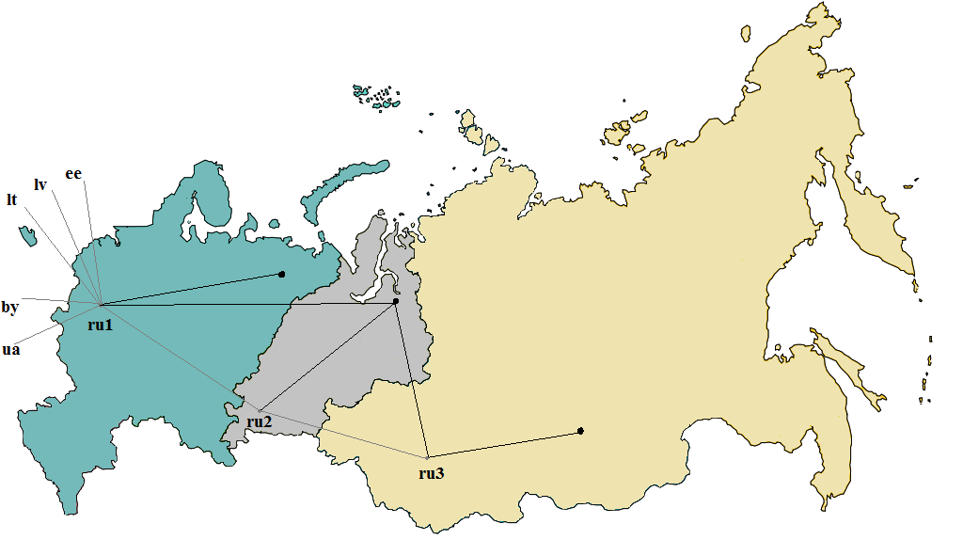The consumption nodes are marked in grey and labelled ru1/ru2/ru3, and the natural gas production nodes are marked in black.
It has not been possible to find data on the actual natural gas trade between the Russian regions. Due to this own assumptions have been made regarding the internal natural gas flows in the base year. In 2009 88% of the Russian gas extraction took place in the Yamal-Nenets region, which is situated in RU2 in the model. From Yamal-Nenets the natural gas pipelines generally go westward or southwest. Due to the way the regions are constructed this means that most of the gas that is extracted in Yamal-Nenets is transported from RU2 into RU1, which covers the western parts of Russia. It is therefore assumed that the gas extracted in RU2, minus the gas consumed in the region, is exported to RU1 before it is exported to Europe. IEA Natural Gas Statistics gives information about the trade flows from Russia (national figures) to Europe and the rest of the world. It is assumed that all the gas that is imported to Europe goes through RU1, as this is consistent with the pipeline structure towards Europe. Russia also has some export of natural gas to the rest of the world. Figure 6 shows how gas can be traded directly from the production node in RU2 (where the majority of the Russian gas is extracted) and the consumption nodes in RU1 and RU3. This is based on where the actual pipelines are situated. RU3 has some export of LNG from the Sakhalin field in the Far East. It is assumed that this is traded directly with ROW (rest of the world).

Table 16: Calibrated international transmission of gas per year (Mtoe)
To  From | EU30 | BY | UA | ROW | RU1 | RU2 | RU3
EU30 | - | 0 | 0 | 0 | 0 | 0 | 0
BY | 8.44 | - | 0 | 0 | 0 | 0 | 0
UA | 84.99 | 0 | - | 0 | 0 | 0 | 0
ROW | 0 | 0 | 0 | - | 24.49 | 0 | 0
RU1 | 3.81 | 23.13 | 111.36 | 0 | - | 0 | 0
RU2 | 0 | 0 | 0 | 0 | 345.80 | - | 3.16
RU3 | 0 | 0 | 0 | 7.33 | 0 | 0 | -

SO (2011) has a table showing transmission of electricity between the seven federal districts (SO 2011). This data has been aggregated to fit the LIBEMOD-regions. There is a slight inconsistency between how the regional power systems are set up and the federal districts that the model regions are based on. In the base year the flows between the regions have been adjusted slightly to ensure consistency within each region. The discrepancy is a result of having to make various assumptions regarding the production and consumption for each region. All electricity traded takes place between the consumption nodes.
No biomass trade takes place between the three Russian regions in the base year. This is due to lack of data and the low level of produced biomass in Russia in 2009 (IEA 2010). RU1 trades with the European countries in the same way as Russia did as an exogenous country.

3.7.3 Prices and Taxes
IEA 2011 (Energy Prices and Taxes) provides prices for some sectors for Russia in 2009. However, because the price of for instance gas and electricity varies considerably between regions and user groups various Russian sources have been consulted to create a more representative set of prices for each LIBEMOD-region. Two scenario reports published by the Agency for Forecasting (under the Ministry of Energy of the Russian Federation) have forecast prices for each of the seven federal regions for 2009 and 2010. These prices are not used directly, but they give an idea of how the prices differ between regions. This information has been used to create regional prices based on the national price from the IEA (Energy Prices and Taxes). In the cases where it has not been possible to find a regional price for an energy source, assumptions have been made based on the available information.
ABPE (2011) has a set of electricity prices by consumer group for each of the federal districts in 2009. The prices for each of the three model regions have been found by taking the weighted average of the prices in the relevant federal districts. The source has prices for 8 different consumer groups. “Industry” has been used for the industry sector, “non-industrial consumers” for the service sector and an unweighted average of “urban population” and “rural population” for the household sector.
Finding end-user prices for the different sectors for natural gas has not been straightforward. Two sets of tariffs for the 83 regions for gas from the Federal Tariff Service (FTS) in Russia have been used as a starting point. These are the prices Gazprom charges the distribution companies, depending on whether they sell the gas to household or wholesale customers. The end-user price to households is also regulated and published each year by the regional tariff authority. To find the end-user prices for households in 2009 regional websites were consulted and a dataset created from the available prices. This, along with the tariffs from FTS, gave an idea of how the end-user price of gas varies from region to region. IEA Energy Prices and Taxes has a national natural gas price for industry in Russia in the base year. This and the regional forecast prices from “Scenario Conditions of Electricity in the Russian Federation from 2009-2020” was used to create the natural gas price for industry for the three LIBEMOD-regions.
IEA Energy Prices and Taxes (2011) has national prices for steam coal and coking coal to industry. “Scenario Conditions of Electricity in the Russian Federation from 2009-2020” has forecast prices for 2009 for the federal districts for coal from different coal fields. This is used to create a regional dataset of prices of steam coal and coking coal to industry and electricity production. For the household sector the industry price with an added distribution cost has been used for each region. For lignite the same source has been used assuming that the prices of coal from coal fields known to produce lignite apply to lignite.
IEA (2011) has a national “heavy fuel oil” price for industry. “Scenario Conditions of Electricity in the Russian Federation from 2009-2020” has forecast prices for oil (to electricity producers) for 2009 for each of the Russian federal districts. The variation in the forecast prices has been used to adjust the IEA price for each LIBEMOD region. For electricity producers the forecast prices have been used (these are close to the industry price from the IEA). For households the regionalised industry prices were used with an added distribution cost. For oil in the transport sector the IEA has national prices for unleaded premium and automotive diesel. These along with daily prices of petrol in the 83 Russian regions were used to get a regional dataset.
For biofuels there is no consumption in Russia in the base year so a price set based on the European price level has been created. Biomass prices are based on wood pellets prices from Rakitova et al. (2009). This report has some pellets prices from 2009 for residential and industrial consumers. A dataset with prices for the three LIBEMOD-regions for all sectors has been created based on this source and own assumptions.
Table 17 End-user prices in RU1 (€2009/toe)
 |  | Households | Industry | Transport | Electricity producers | Services
Electricity | €₂₀₀₉/TWh | 37.00 | 37.43 | 37.43 | - | 58.00
Gas | €₂₀₀₉/toe | 60.49 | 83.69 | - | 83.69 | 83.69
Steam coal | €₂₀₀₉/toe | 255.30 | 72.29 | - | 72.29 | 255.30
Coking coal | €₂₀₀₉/toe | - | 146.05 | - | 146.05 | -
Lignite | €₂₀₀₉/toe | 239.02 | 58.49 | - | 58.49 | 239.02
Oil | €₂₀₀₉/toe | 442.88 | 211.90 | 423.23 | 211.90 | 442.88
Biofuel | €₂₀₀₉/toe | - | - | 1288.93 | - | -
Biomass | €₂₀₀₉/toe | 1231.65 | 295.60 | - | 295.60 | 1231.65

Table 18 End-user prices in RU2 (€2009/toe)
 |  | Households | Industry | Transport | Electricity producers | Services
Electricity | €₂₀₀₉/TWh | 26.98 | 40.04 | 40.04 | - | 59.46
Gas | €₂₀₀₉/toe | 52.09 | 64.74 | - | 64.74 | 64.74
Steam coal | €₂₀₀₉/toe | 224.86 | 46.49 | - | 46.49 | 224.86
Coking coal | €₂₀₀₉/toe | - | 123.36 | - | 123.36 | -
Lignite | €₂₀₀₉/toe | 220.55 | 42.84 | - | 42.84 | 220.55
Oil | €₂₀₀₉/toe | 424.67 | 196.47 | 449.10 | 196.47 | 424.67
Biofuel | €₂₀₀₉/toe | - | - | 1288.93 | - | -
Biomass | €₂₀₀₉/toe | 718.46 | 172.43 | - | 172.43 | 718.46

Table 19 End-user prices in RU3 (€2009/toe)
 |  | Households | Industry | Transport | Electricity producers | Services
Electricity | €₂₀₀₉/TWh | 27.57 | 28.08 | 28.08 | - | 46.35
Gas | €₂₀₀₉/toe | 64.15 | 60.27 | - | 60.27 | 60.27
Steam coal | €₂₀₀₉/toe | 235.62 | 55.61 | - | 55.61 | 235.62
Coking coal | €₂₀₀₉/toe | - | 115.78 | - | 115.78 | -
Lignite | €₂₀₀₉/toe | 215.04 | 38.17 | - | 38.17 | 215.04
Oil | €₂₀₀₉/toe | 447.15 | 215.52 | 470.08 | 215.52 | 447.15
Biofuel | €₂₀₀₉/toe | - | - | 1288.93 | - | -
Biomass | €₂₀₀₉/toe | 718.46 | 172.43 | - | 172.43 | 718.46

3.7.4 Elasticities
When Russia is an exogenous country in the model the demand elasticities are set to half of the European average for coal and natural gas and 2/3 of the European average for oil (see chapter 3.1.8). It is assumed that the ratio between the short-term and the long-term elasticities is the same as for the European countries. Between the sectors we use the same ration as for the country with the lowest elasticities in Europe. When Russia is endogenous RU1, RU2 and RU3 all have the same elasticities.
For natural gas the long-run elasticity is set to -0.31 for households. This reflects the inelastic demand in Russia today as a result of energy subsidies, non-payment issues and lack of gas metering among household customers (OECD 2004, Pirani 2011). The elasticity is gradually increased over time, which reflects that it is expected that the price household consumers face will increase substantially over time as a result of less subsidies. Assuming that the Russian problems with non-payment and lack of gas metering are addressed in the future, gas demand is expected to become gradually more price responsive. The same cross-price elasticities as for the other model countries (see chapter 3.1.5) are used for the three regions.
The income elasticities are the same as when Russia is an exogenous country. These have been calibrated using average projected annual GDP growth rates from 2009 to 2035, average projected annual growth rates in energy consumption (for each sector and energy type) along with corresponding projected energy prices, and the price elasticities we use in the model (see above). The income elasticities can then be calibrated as the non-price changes in consumption relative to the changes in GDP. Regional GDP figures have been used (see 3.7.5).

3.7.5 GDP Growth rates
When Russia is an exogenous country national projections from the World Bank for GDP growth from 2018 to 2030 have been used. Based on these sources the average annual GDP growth in Russia as a whole is 4.3 % between 2009 and 2035. From 2030 to 2050 we have used World Bank projections of population growth, and assumed a gradual reduction in GDP per capita growth rates towards 1% p.a. from 2030 to 2050. This national growth rate is used to calibrate regional growth rates in Russia. To create regional indexes two additional sources have been used: historical gross regional product for the Russian regions from Rosstat and regional population data from the Russian population census of 2002 and 2010 (along with estimates for 2012) from the “State Committee of the Russian Federation on Statistics”. For the three regions we then get the following average GDP growth rates between 2009 and 2035; RU1 4.5 %, RU2 3.4 % and RU3 4.3 %.

3.7.6 CES demand parameters
For Russia the regional values for final consumption expenditures are taken from national account data for gross regional product from Rosstat (www.gks.ru). Rosstat has data on final consumption expenditure for households, but only at national level. To allocate this to the three regions we used “Average per capita monthly expenditures on good and services” by region as a proxy for how much of the consumption that takes place in each region.
To find the gross value of production by sector for each region, we have used regional data on the “Sectorial structure of the gross value added of the Russian Federation” in 2009 (www.gks.ru), along with the gross regional product for each region.

3.7.7 Supply of fuels
Supply is modelled in the same way as for the other model countries. IEA Extended Energy Balances has been used as the main source for total production data for Russia (see chapter 3.2.1). To regionalise these several sources have been used. Rystad Energy has unofficial regional data for oil and gas production. This detailed dataset has been aggregated and a set of parameters have been calibrated for gas and coal for the three regions. For coking coal and steam coal the parameters used when Russia is an exogenous country (see chapter 3.2.1) are regionalised through using regional production data from Statistical Yearbook of Russia (2009). Despite having a large biomass potential, production of biomass is not well developed in Russia due to the costs being high compared to other energy alternatives. There is little production in the base year, and due to lack of data, it is assumed that the biomass production is split equally between the three regions. Russia does not have any production of biofuels in the base year.

3.7.8 Supply of renewables
To estimate the hydropower potential in RU1, RU2 and RU3 the total for Russia from World Atlas and Industry Guide (2011) was used as a starting point. Black and Veatch provide information about how the potential is distributed between the federal districts. Half the potential defined as “economic” has been used. This is in line with the approached used for the other model countries in order not to overestimate the hydropower potential (see chapter 3.2.2).
The inflow capacity in a hydrological normal year is defined as the amount of precipitation that reaches the catchment area and is available for hydropower production. For the three regions the inflow proxy was created using data from the System Operator of the Unified Energy System of Russia (SO UES). This is done by using the average net reservoir hydropower production per unit net reservoir hydropower generation capacity for the years 2009 - 2012, which is then multiplied by the net generation capacity of the base year 2009. The result is a region-specific estimate of inflow capacity in a hydrological normal year.
This has been supplemented with information about the pumped storage production and capacity from RusHydro (2010). It is assumed that there is no run-of-river capacity in the base year, however a share of the potential can be used for run-of-river development in future years. Due to lack of data sources on reservoir capacity and filling shares in Russia the same approach was used for the three Russian regions as for other model countries with no data (see chapter 3.2.2).
The solar power potential in the three regions is based on the same sources as for the rest of the model countries. Through the NASA database the best and worst locations for solar insolation were found, using the same dataset as outlined in chapter 3.2.3. After finding 0.5 % of the agricultural land in Russia it was allocated to the three regions through the use of a map of agricultural areas in the country.
Table 20 Solar insolation kWh/m²/year (Average radiation incident on an equator-pointed tilted surface)
Country | Best (angle) | Worst (angle)
RU1 | 1521 (28) | 917 (53)
RU2 | 1359 (40) | 1014 (50)
RU3 | 1531 (33) | 921(54)

The wind power potential in each region was found using several sources. IEA (2003) has a map of wind resources in Russia, which was used to find the wind hours at the best site in each region. For RU1 and RU3 this was assessed to 3700 hours, which is the same as the best wind sites in Europe. For RU2 it was assessed to 3100 hours per year. Data for Norway adjusted by a country size factor was then used to find the parameters for each of the regions.
Table 21 Wind hours at best site in Russian regions
Country | Best (wind hours)
RU1 | 3700
RU2 | 3100
RU3 | 3100

3.7.9 Electricity generation
The same approach as for the other model countries has been used, with IEA Electricity Information as the main data source. To regionalise the data for electricity production APBE (2010) has been used. This publication provides production of electricity in power stations by fuel type, which allows the allocation of the use of coal, natural gas and oil to each region. For coal it is assumed that the same allocation applies for steam coal and lignite. This may cause the production shares from the different coal types to be flawed, but ensures that the total production from coal in each region is correct. For generation from biomass and waste no sources have been found, so the consumption has been allocated based on population shares.
Heat production has been included in the data in the same way as for the other model countries, using the same conversion factors from heat to electricity. To allocate the heat produced from each fuel to each region the total for each sector from the IEA and the total for each region from APBE (2010) have been used. To allocate the heat production between the fuels for each region the distribution of the electricity production by fuel has been used as a guideline. This approach seems reasonable as combined heat and power plants (CHP) make up around a third of the installed generating capacity in Russia.
SO (2011) reports capacity data for hydro, nuclear and thermal power plants for the seven federal districts. Knowing only the total capacity for coal, natural gas and oil in each region more detailed power plant data for Russia was used to split each region’s capacity into fuel type. GeoHive and Enipedia have information about single plants with their location and capacity. This has made it possible to allocate plants to each region. However, the many multi-fuelled power plants are complicating the picture. Where power plants operate on several fuels they have been allocated according to their primary fuel type. For hydropower the total for each LIBEMOD-region is allocated to reservoir capacity, apart from in RU1. RusHydro Annual Report for 2009 has information about a pumped storage power plant located in RU1 and its capacity, which is then deducted from the total hydro capacity given by SO UPS (2011). It is assumed that there is no run-of-river capacity in the base year. The nuclear capacities can be allocated directly to the regions, whereas for the thermal power capacities other sources have been used.

3.7.10 Transportation of natural gas
ENTSOG and East European Gas Analysis (EEG) have capacities for the export pipelines that run from Russia into Europe. The largest Russian natural gas fields that are currently connected by pipeline are located in the Yamal-Nenets region. This is situated in the Ural Federal District, which is in RU2 in the model. Several of the main pipelines connect this area with the western part of Russia and Europe. Through using several maps of the Russian gas pipeline network (EEGA, Petroleum Economist 2011), and an overview of existing infrastructure (Nies 2011), a set of capacities between the three Russian regions have been created.
Figure 7: Map of the natural gas pipelines of Russia
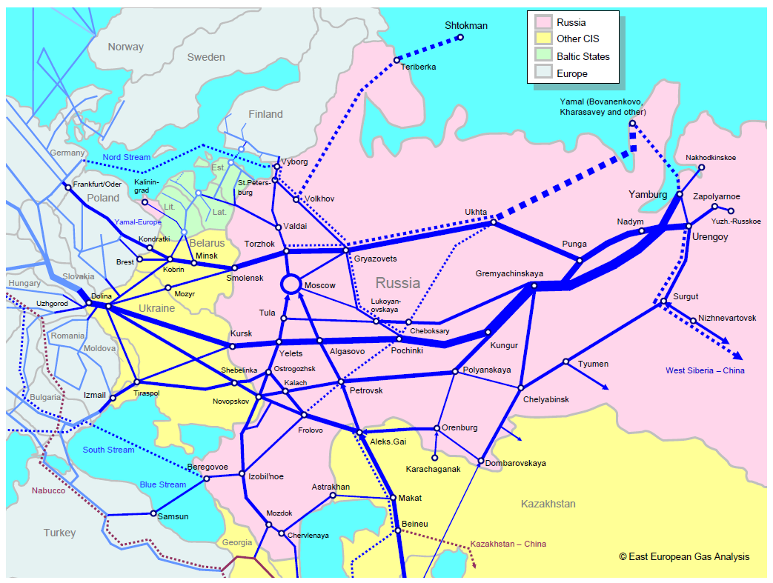
Source: East European Gas Analysis http://www.eegas.com/fsu.htm.
All export towards Europe goes through RU1, i.e. the export capacities between the European countries and Russia are used. The capacity between RU2 and RU1 is assumed to be larger than the export capacity as the pipelines are also used for domestic transport of gas. Based on the pipeline maps some capacity is added between RU2 and RU3 (from Surgut and Tyumen into Western Siberia). It is also assumed that RU3 has some capacity towards the rest of the world (row), although this is currently only from the gas fields in the eastern parts of the Far East. This is based on data from ENTSOG.
Table 22: Initial international transmission capacities for gas (Mtoe)
To From | EU30 | BY | UA | ROW | RU1 | RU2 | RU3
EU30 | - | 0 | 41.51 | 0 | 3.92 | 0 | 0
BY | 15.06 | - | 0 | 0 | 0 | 0 | 0
UA | 161.95 | 0 | - | 0 | 0 | 0 | 0
ROW | 10.12 | 0 | 0 | - | 0 | 0 | 0
RU1 | 60.82 | 33.44 | 137.58 | 71.06 | - | 0 | 0
RU2 | 0 | 0 | 0 | 0 | 382.16 | - | 19.11
RU3 | 0 | 0 | 0 | 8 | 0 | 0 | -

The Federal Tariff Service provides a set of regulated tariffs that the distributors pay Gazprom for the gas in all the 83 regions (see chapter 3.7.3). These prices vary with the proximity of the regions to the gas fields. When a tariff is calculated based on the difference in the price to industry between the regions closest to the gas field (Yamal-Nenets Autonomous District) and regions close to where the pipeline passes on its way to the border to Ukraine, the cost per toe/100 km is very close to that found based on WEO (2009) data used for international transportation of gas (see chapter 3.5.1.3). Based on this it is assumed that the same transportation costs apply between the Russian regions as for the rest of the model countries.

3.7.11 Transportation of electricity
Abdurofikov (2009) provides transmission capacities between 28 electricity zones within Russia. These zones do not correspond completely to the federal districts, as there is one zone which is made up of parts of the Ural Federal District (RU1) and parts of Volga Federal District (RU2). This whole zone has been included in RU1.
To find the operating and maintenance costs of electricity transmission between the regions exactly the same approach as for the other model countries has been used (see chapter 3.5.2.3 in the main documentation of LIBEMOD).

References
For a list of all references used for Russia and in LIBEMOD in general see the main documentation of LIBEMOD or https://www.frisch.uio.no/docs/LIBEMOD/references/ .

УКАЗ Президента РФ от 13.05.2000 N 849 "О ПОЛНОМОЧНОМ ПРЕДСТАВИТЕЛЕ ПРЕЗИДЕНТА РОССИЙСКОЙ ФЕДЕРАЦИИ В ФЕДЕРАЛЬНОМ ОКРУГЕ". Graph.document.kremlin.ru (2000-05-13)
North Caucasus Federal District was split from Southern Federal District in January 2010, so in the data sources it varies whether it is split into 7 or 8 districts. However, for our use this makes no difference as they are both part of RU1.
Отчет о функционировании ЕЭС России в 2010 году – “United Energy Systems (UES) of Russia 2010 operations report”.
http://solex-un.ru/energo/reviews/avtomobilnyy-transport/obzor-1
Due to lack of sources an allocation had to be made. It is loosely based on the location of oil-fired power plants in Russia.
These regional power systems are not totally overlapping with the federal districts for Volga and Ural (http://so-ups.ru/index.php?id=fops), but when APBE (2010) uses Volga and Ural in their data we assume that this is in keeping with our definition of the regions.
Russia is divided into 83 smaller regions and in the official tariffs for gas, and minimum and maximum prices for electricity, we therefore have sets of 83 prices. As mentioned, the forecast reports operate with the seven federal regions, whereas we in our model have tree regions. We have therefore used averages, sometimes weighted on population, to get a set of three regional prices.
http://www.fstrf.ru/tariffs/info_tarif/gas
The data available for each region varied considerably. Most regions only had data for the current year (2013) on their websites. We gathered the 2009-prices that were available, and also looked to the differences in price between regions in the 2013-data as it is assumed that the increase in the gas price has been relatively similar across regions (based on federal policy).
This is based on the distribution costs of coal to households in Eastern Europe.
This is not clearly specified in the report, however with the names of the extraction areas it is possible to identify a few coal mines where brown coal (lignite) is extracted.
This is based on the distribution costs of oil to households in Eastern Europe.
Found through www.minenergo.ru. This online tool provides daily prices of petrol, but only a few months back (beginning of 2013). We therefor implicitly assume that the regional differences stayed the same between 2009 and 2013.
Source: http://www.gks.ru/wps/wcm/connect/rosstat_main/rosstat/ru/statistics/accounts/#
Source: http://www.gks.ru/wps/wcm/connect/rosstat_main/rosstat/ru/statistics/population/demography/#
http://www.gks.ru/wps/wcm/connect/rosstat_main/rosstat/ru/statistics/accounts/
http://www.gks.ru/bgd/regl/b11_06/IssWWW.exe/Stg/d04/17-01-1.htm
http://www.gks.ru/wps/wcm/connect/rosstat_main/rosstat/ru/statistics/accounts/#
Russia country profile prepared by Black and Veatch (B&V) for the European Bank for Reconstruction and Development. http://storage.globalcitizen.net/data/topic/knowledge/uploads/20111011161523705.pdf
Source: http://www.sras.org/the_medvedev_economy
No sources were found.
CHP/DHC Country Profile: Russia (The international CHP/DHC Collaborative).
http://www.eegas.com/fsu.htm

